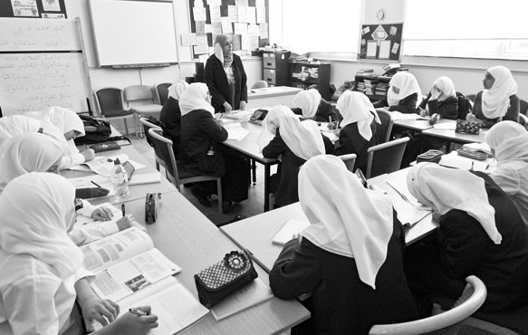

**T H R O U G H T H E G A T E S**

**A guided visit to**

**Islamia Girls School**

**and Al-Sadiq and Al-Zahra School**

**Opened by Guest Speaker**

**Tulip Siddiq MP**

**Monday 21 September 2015**

An International Peace Day Event

10.30am – Lunch time

*The event starts at London Inter Faith Centre,*

*126 Salusbury Road, NW5 5RG. Doors open at 10.15am for a prompt start at 10.30.*

*The visit concludes with a delicious lunch*

**The London Inter Faith Centre, together with the staff and students of Islamia Girls School and Al-Sadiq and Al-Zahra Schools** have pleasure in inviting local residents, neighbours and friends to a morning to see inside their schools.

Both schools are faith schools. Islamia Girls School founded by Yusuf Islam, formerly singer/songwriter Cat Stevens, serves a predominantly Sunni community. Al-Sadiq and

Al-Zahra are schools of the Al-Khoei Foundation and serve a predominately Shia community.

The event will include a tour of the schools and time for questions. ­­­The visit may include a tour of the Mosque; please dress modestly and for women, bring a scarf to cover your hair. *This is a timetabled event and it is only possible to join the guided visit at 10.30 at the London Inter Faith Centre.*

**All are welcome.**

**This is FREE event but PLACES MUST BE REGISTERED IN ADVANCE.**

For registration and further information contact Jo Winsloe Slater:

m: 07899 450307 e: [jo.winsloe@londoninterfaith.org.uk](mailto:Jo.winsloe@londoninterfaith.org.uk)